**

**. . for family and friends of the Uniting Church in the Northern Synod**

|  |
| --- |
|  |

**A VOICE OF REASON** September 2023

Dear Friends,

I write to you at this most wonderful time in the history of our country.

We have a Referendum on October 14th. Everyone’s opinion, everyone’s vote, counts.

I wonder if we really know how fortunate we are to have this opportunity.

This is a moment in history. It sits in line with the 1967 Referendum, 1975 Wattie Creek land-rights, the 1992 Mabo ruling which rendered ‘terra nullius’ a legal fiction and the 2008 Apology to the Stolen Generations. Slowly, but surely we as a nation, are recognising the existence of and the rights of our Indigenous brothers and sisters as First Nations peoples of these lands.

Now we are being asked to decide as a nation, whether we will listen to advice from First Nations people about issues that directly affect their lives and communities.

On the surface that looks like a simple matter. “Of course, we should listen,” I hear you say.

Of course, listening to those who are most affected by decisions, will help better decisions to be made and lead to better outcomes. That’s just common sense, isn’t it? On the surface it looks simple. And that’s because it is simple.

If you are feeling confused or unclear, that is because some people are trying to confuse you. Don’t get sucked into their divisive game. It’s not hard to understand. It’s really, very straight forward.

Australia has a chance to establish an advisory group of elected First Nations leaders who will offer advice to the Parliament on matters that affect Aboriginal and Torres Strait Islander people. This will be set into the Australian National Constitution, so that it cannot be cast aside by any future change of government.

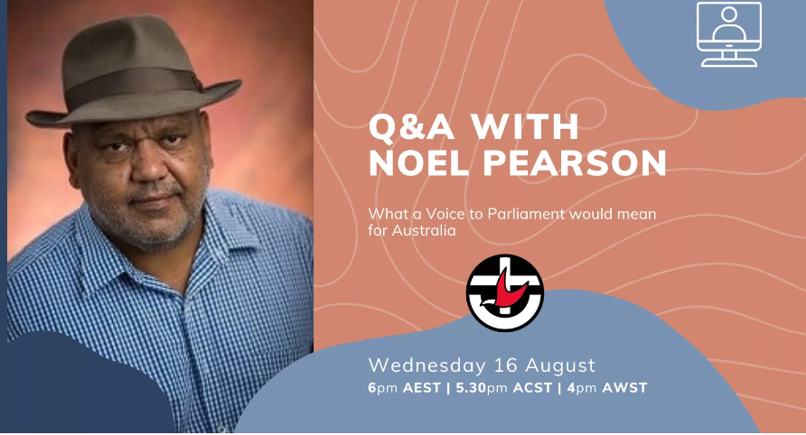

Q and A with Noel Pearson “What a Voice to Parliament would mean for Australia”

<https://uniting.church/qa-with-noel-pearson/>

In 2018 many Aboriginal leaders gathered at Uluru in response to the then Government who asked them what they wanted to see happen to improve the disadvantage that so many First Nations people experience. One thing that came out of this gathering was a call for Treaty, Truth-telling and an advisory Voice to Parliament. This was done with a generosity of spirit from First Nations people, inviting all of us Australians to come together for a better future for all.

Here we are now in 2023 and a proposal for the advisory Voice to Parliament is going to be put to the Australian public. A referendum is a wonderful tool. Everyone of voting age is being asked if they support a Voice to Parliament or not. We are not voting for a government. We are voting for an issue. Each and every person of voting age has the right to vote YES or NO on this issue.

Your vote matters and you should vote according to your conscience. The purpose of this letter is to encourage you to be informed. There is a lot of noise going on and it is easy to find that noise distracting or confusing. Try to avoid getting drawn into the social media arguments that can so easily turn into ‘lowest common denominator’ arguments, or the one-line slogans that try to politicise this as some kind of fight for the smartest jingle.

This is a serious issue that will have important consequences for years to come.

It is not a political issue. It is a Human issue. Those who are playing politics with this should take a long look in the mirror. It is a Human issue about a better way forward to improve severe disadvantage for many of our most vulnerable people.

With this in mind, I have included below some references to what I consider to be well-balanced and helpful resources where you can get some good information.

At the heart of the Uniting Church is a commitment to walk together with First Nations people in seeking justice. We seek to work and pray together as First and Second Peoples for more just, inclusive and equal relationships in the church and in this nation. Inspired by this commitment, we support a constitutionally enshrined Aboriginal and Torres Strait Islander Voice to Parliament as an historic opportunity to recognise and honour First Nations people and to walk together as a nation toward a better future.

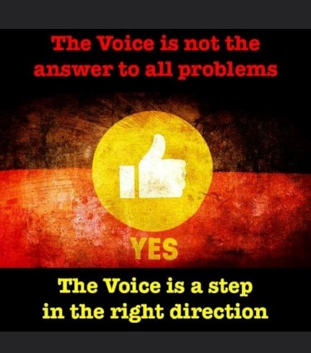

I will be voting YES on October 14th. If you are unsure, I encourage you to consider voting YES. Check out the resources below. I am happy to talk with anyone about this in a respectful way, if you want. Just call me.

<https://uniting.church/a-voice-to-parliament-in-2-pages/>

<https://uniting.church/voice/>  
<https://yes23.com.au/>  
<https://ulurustatement.org/>  
<https://www.ncca.org.au/first-nations-resources/resources/item/2991-a-voice-to-parliament>

Be informed. Your vote matters. History is calling.

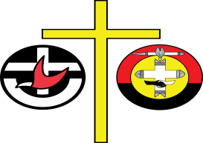

The Uniting Church in Australia

Northern Synod

2 Railway St, Parap NT 0820

Postal: PO Box 38221,

Winnellie NT 0821

Ph: 08 8982 3400  Fax: 08 8982 349

admin@ns.uca.org.au

The best is yet to come,



Rev Tony Goodluck

Nangarridj

**Moderator**

**Northern Synod**

**Uniting Church in Australia**

Mob: 0498 680 215

Email: [tony.goodluck@ns.uca.org.au](mailto:tony.goodluck@ns.uca.org.au)

*Living on* ***Larrakia*** *land*

*Born on* ***Jaitmatang*** *land*

*Raised on* ***Jaitmatang****,* ***Woiworunn****,* ***Maarku*** *and* ***Larrakia*** *land*