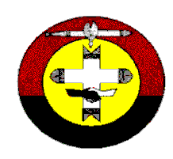 | northern regional council  of the  uniting aboriginal & islander christian congress  UNITING CHURCH IN AUSTRALIA  ABN 90 769 121 873  Postal: PO Box 38221 Phone: 08 8982 3400  Winnellie NT 0821 Fax: 08 8982 3499  Email: nrccadmin@ns.uca.org.au
 | Position vacant
AṈANGU EDUCATOR

NRCC is seeking a person to conduct training and education of its members living in the APY Lands of northern South Australia. This is a position that is open to a Minister of the Word, Deacon or Pastor.

The Position Description should be read before applying. Particular reference should be made in the application to the qualifications and experience needed.

Applications are to be sent to:
Howard Amery
NRCC Resource Worker
PO Box 38221
Winnellie NT 0821

Email: howard.amery@ns.uca.org.au

Phone 8982 3400 or 0484 844 663

Applications are due by 13th December 2019

