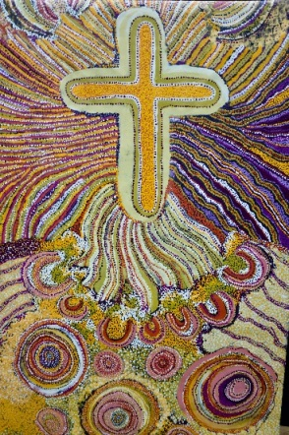
UNITING CHURCH IN AUSTRALIA
NORTHERN SYNOD

43rd Annual Synod Meeting
Sharing your life message

Reflection on Synod Theme

~ Sharing your Life Message ~ will be the theme of the synod over the next two years.

The Northern Synod is one synod full of diversity. This diversity should be gratefully accepted as God's gift that must be valued. This theme was chosen based on personal experience and struggle with our brothers and sisters as First People on this land. In visits to their communities I often hear stories of those who live in trauma and feel marginalized but uphold their culture. Sometimes they are not able to share their stories fully because they cannot express it in our language. They have many stories to tell about culture, especially those related to the natural surroundings created by God.

Serving in diversity is the greatest strength for us, therefore each of us have experiences in this life. Whether it is with our families, or in the church now or many years ago. If we are willing to share these experiences with others as testimonies it can become a wise tool to enlighten our brothers and sisters as to how good God is in our lives. God wants us to share our experience with others because your message is an essential part of your mission on earth. There is no other message just like yours, so only you can share it. If you don’t share it, it will be lost forever.

Your life message includes your life lessons and the truth that God has taught you from experiences with him. These are lessons and insights you have learned about God through relationships, problems, temptations and other aspects of life. Whoever believes in God’s Son has eternal life. ( “ All who believe in the Son of God know in their hearts that this testimony is true” 1 John 5:10a ).

He is all you need to work for it, you don’t need to wait for eternal life because it begins the moment you believe. You don’t need to work for it because it is already yours. You don’t need to worry about it because you have been given eternal life by God himself and it is guaranteed. When you share your message you build a relational bridge that Jesus can walk across from your heart to others.

~I love to tell the story, of unseen things above,
Of Jesus and His glory, Of Jesus and His love:
I love to tell the story because I know ‘tis true
I love to tell the story ‘Twill be my theme in glory~

Moderator
Rev Thresi Mauboy Wohangara

