Memorial Minute
Celebrating the life of Rev Christopher John Paine
4th September 1962 – 22nd August 2017

Christopher John Paine was born at Dubbo in the early hours of
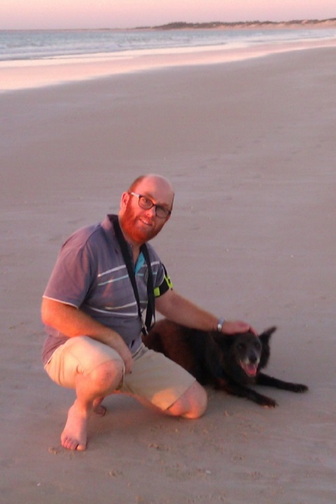
Tuesday 4th September 1962. He was Neville and Lee Paine’s
4th child and a younger brother for Leone, William and
Denise. The family moved to Harden for a few years before
returning to Mudgee as Chris started school. He attended
Mudgee Public School and Mudgee High School and was involved
in Sunday School, Youth Group and worship at Mudgee Methodist
church which became Mudgee Uniting church. Chris loved and
cared for his family . He shared the families strong faith in God.

After high school, Chris moved to Wollongong University to
study computing and work at the Steelworks. He became part
of West Wollongong Uniting Church. He boarded with an older
lady who darned his socks, fed and cared for him. At an early age he
took a redundancy and then commenced a job at the Uniting
Church Synod Office in the centre of Sydney, commuting from Wollongong each day. Chris moved to Westmead and discerning God’s call he trained for the ministry at Uniting Theological College. After his ordination Chris served the people at Nyngan, Moss Vale, Dubbo and Broome.

At the age of 50 Chris married Helen and together, after 12 months in Sydney, they took up a joint ministry placement in Broome. During 2016/2017 Chris faced a battle with cancer. He died of a brain tumor on the morning of 22nd August 2017, two weeks short of his 55th birthday.

Chris is remembered for his playfulness, his pastoral heart, his humor and his courage. He was always actively involved in the church, which he loved. At Synod and Presbytery meetings he usually had a camera in his hand and captured many special moments. He had a memorable sense of humour which he regularly shared at morning tea under the Cashew Tree on Saturday mornings at Op Shop and again on Sunday morning during and after worship. One of is special pleasures was to sing and he made a significant contribution to the local Broome Choir. He is remembered in Broome for being attentive and interested in local events and was regularly seen walking with his much loved dogs.

At Chris’ Memorial Service in Broome, young Stuart (4year old member of the Broome Congregation) told me that “in those last days Chris had become smaller and smaller and now he was gone. He is now free and can go anywhere and visit who ever he wants to, everywhere”.

Memorial Prayer
Loving God, within us there is mourning, an empty space which was once filled by Chris, part of our journey that has suddenly stopped, a sense of ourselves that is no longer here, a way of being and living which is gone. Within each one of us there is loss.
Silence
Eternal God, your love for us is everlasting. You alone can turn the shadow of death into the brightness of the morning light. In your comfort, we can show dignity and care, share the stories of our journey with Chris and have the courage to hold the memories as we continue our journey.
Help us to forgive Chris anything that was hurtful to us, and to forgive ourselves for those things left unresolved from our journey with him.
Enable us to claim the blessing that he was in our lives.
By the power of the Holy Spirit, come to us in our loss with the light and peace of your presence. Speak to us through your Holy Word that our faith might be strengthened and our hope sustained through Jesus Christ our Lord. Amen.

Prepared by
Rev Felicity Amery
Chairperson/Presbytery Minister PPNA
For 42nd Meeting of the Northern Synod

Friday 5th October 2018

