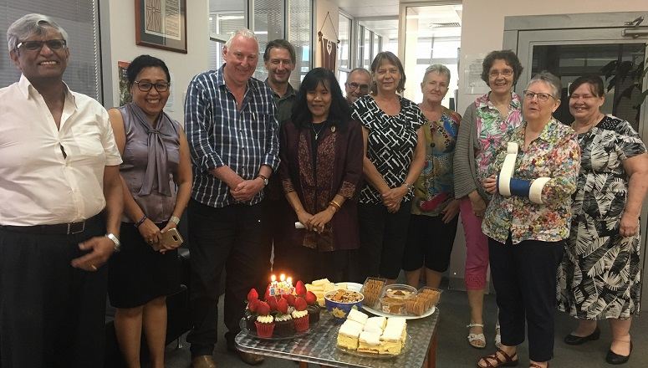
YOU ARE INVITED TO PETERS FAREWELL AFTERNOON TEA

THURSDAY 13TH DECEMBER 2.00PM RSVP 7TH DECEMBER
AT SYNOD OFFICE EMAIL ADMIN@NS.UCA.ORG.AU

