  

**Uniting Church in Australia Northern Synod**

Moderator, Rev Thresi Mauboy Wohangara

together with the Northern Regional Council of Congress

and the Pilgrim Presbytery of Northern Australia

is pleased to invite you

to the

Induction of

Reverend Haloti Kailahi

as new Synod General Secretary

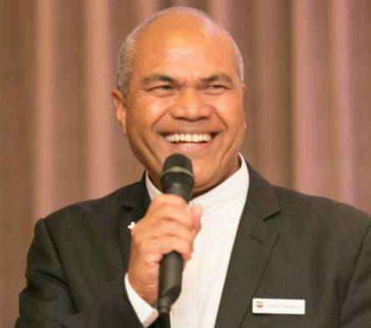 

**Casuarina Uniting Church, Vanderlin Dr Wanguri**

**Friday 14 December 2018**

**6.30pm Arrival for a 7pm service**

*A supper will follow after the service*

RSVP by Monday 10 December 2018

Email [admin@ns.uca.org.au](mailto:admin@ns.uca.org.au) Phone: (08) 8982 3400