2nd August 2018

Dear Ministers, Pastors and members of Congregations

A Pastoral Letter from the Presbytery Minister

Greetings and prayers to you all as you seek to be the activity of God in and through your congregations and communities.

It is now three weeks since the conclusion of our very special triennial meeting of the National Assembly. All our attendees have returned home, reconnected with family and friends and resumed their various ministry tasks. The theme of the Assembly for this triennium is Abundant Grace and Liberating Hope. This theme will continue for the next three years, and along with the decisions of the Assembly, inform the activities of its ‘Circles’ (Working Groups) and Agencies. It is a theme that embraces the generosity and hospitality of God, the reconciling love of Jesus and the courage offered to us in the company of the Holy Spirit.
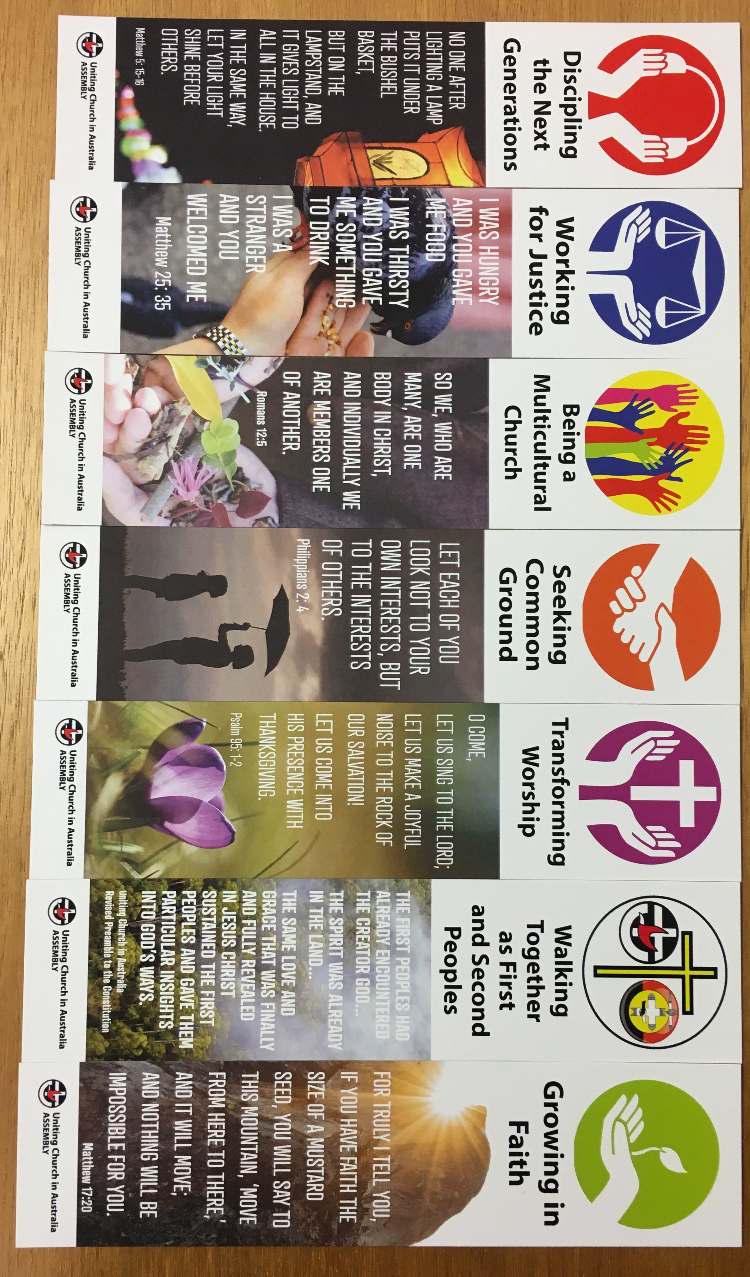
The restructuring of the Assembly from National
Working Groups to Circles with Advocates and a new
multi purpose Resource Team, offers a fresh and new
way of engaging and resourcing the church. There are
seven Circles, Discipling the Next Generation, Working
for Justice, Being a Multi-Cultural Church, Seeking
Common Ground, Transforming Worship, Walking
Together as First and Second Peoples, and Growing in
Faith. We encourage you to join a Circle that might support the ministries of your congregation or to be resourced in a new missional initiative that your congregation is exploring. The Assembly Resourcing Unit, including a Theologian in Residence is headed up by Rev Rob Floyd who can be contacted through the Assembly website.

During the Assembly the Northern Synod ’Team of Ten’ led worship on Wednesday. Maratja and Djawut opened with digeridoo and clap sticks, Djawut read the scripture (Ezekiel 37) in Djambarrpuyngu. We led singing in English Djambarrpuyngu and Pitjantjatjara and prayers for the Northern Synod and the Assembly. It was a very special time of ministry and many people where strongly encouraged.

As you know many reports were presented, proposals explored and tested and discussions had. The meeting was very well resourced by a series of Working Groups that we all belonged to. This enabled us all to discuss openly and safely the many topics before us. I would like to share some of these with you.
We received a report from the Working for Justice Circle on climate change. It is now 10 years since the last statement was made by the Uniting Church on these matters. We agreed to encourage and resource Congregations, Presbyteries and Synods to be aware of the issues, advocate for and support communities at risk and listen to and learn from the voices of the vulnerable people around the world. This will mean taking action in our local communities on issues related to climate change.

We received and strongly affirmed a statement on Domestic and Family Violence. Recognising broad community concern, the church wants to be very clear in repudiating domestic and family violence and expressing God’s desire for life-giving, mutually respectful relationships in homes and in the community. The Assembly affirmed a strong commitment to educate resource and support members to be aware of this reality and to develop safe practices and spaces in our congregations, agencies and schools.

The Assembly received a Proposal from the Vic/Tas Synod seeking support for work to be done on the issue of Voluntary Assisted Dying. This was discussed. However the Assembly was not able to come to consensus or agreement about a way forward, so the proposers withdrew their request for this work to be done.

A series of ballots lead to the announcement of a new President Elect. Following the leadership of our current President Deidre Palmer, the Rev Sharon Hollis will be the President. She is currently the Moderator of the Vic/Tas Synod.

There were at least seven proposals received by the house on Marriage and same gender relationships. Discussion in working groups and on the floor of the Assembly produced a few more. Finally the Assembly received and supported by formal meeting procedures and a secret paper ballot, Proposal 64 on Marriage. As you will know from the President’s communications, we agreed to two definitions of marriage which read the same except for the opening sentences. One says marriage is between a man and a woman and the other says that marriage is between two people. There will be opportunity to discuss this and other proposals and their implications at Presbytery in October. Please contact me if this proposal has generated concern in your congregation as the Moderator or myself would be very happy to visit and discuss it with Church Councils and Congregations.

There was further discussion at Assembly about membership in the Uniting Church. This work was referred to the Assembly Standing Committee and again we will have opportunity to discuss this proposal at our Presbytery meeting in October.

Now Past President, Stuart McMillan, with Assembly General Secretary Colleen Geyer, brought a proposal encouraging the Uniting Church to affirm that the First Peoples of Australia, the Aboriginal and Islander Peoples, are sovereign peoples of this land and to stand with them by virtue of our Covenant relationships with them. This was strongly supported by the Assembly and will be resourced through the establishment of an Assembly Consultant - Covenanting. The Northern Synod was excited to hear yesterday that the Assembly had made an appointment and that Stuart McMillan will undertake that work on behalf of the church. We offer our congratulations and blessings to Stuart as he continues to offer his gifts and skills for ministry both within the Uniting Church and with First Peoples.

Further there was a proposal brought by Rev Gary Dronfield, the new President of UAICC to encourage Synods to enter into conversations with Congress that will lead to a series of Memorandums of Understanding that articulate the rights, obligations and responsibilities in these relationships. This also was strongly affirmed.

Another big issue before the Assembly was the Uniting Church’s commitment to and participation in the National Redress Scheme for victims of child sexual abuse. We noted the extensive work done by our National Task Group to ensure our participation in a just and equitable redress, the work being done to create a Safe Church Unit in the UCA and work being done on a Professional Standards Project. We delegated the responsibility for oversight and final approvals to the Assembly Standing Committee who will in consultation with the Legal Reference Committee make any necessary changes to the regulations needed to implement new policy and practices. This has been a complex and distressing piece of work for the church and we thank Rev John Cox for his leadership in these matters.

Members of the Circle on Being a Multicultural Church, Rev Kisoo Jang and Rev Jason Kioa brought a proposal requesting the Assembly Standing Committee to develop processes to recognise languages other than English. The intent of the proposal is to recognise the growing cultural and linguistic diversity of the church and encourage us to normalise the use of languages other than English in worship, leadership training and phases of formation. You will notice on the Assembly website a growing number of documents in languages other than English. The Assembly was delighted to affirm this proposal.

While I hope this letter gives you a glimpse of what issues the Assembly sort to address, the next addition of the Northern Synod News is in its final stages of preparation and will give you another look at the many highlights of our national gathering. You will see the involvement of young people, the welcoming of ecumenical guests and participation of our overseas partner churches. You will hear about the significant contribution of the Bible Study Leaders Rev Dr Seforosa Carroll and Rev James Bhagwan from Fiji.

Please continue to pray for the Assembly and its staff as they seek to faithfully serve God through the church and be encouraged to actively participate in this work through the Circles or your local ministry and mission.

Under the grace of God
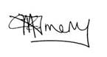
Rev Felicity Amery
Chairperson/Presbytery Minister

