Pilgrim Presbytery of Northern Australia
Report to the Northern Synod
1st October 2018
Prepared by Rev Felicity Amery

When we read and think about the Bible, the stories remind us that we are a diverse people called and equipped by God’s grace to be in relationship with God and our neighbours. Our relationships with God and with our neighbours are not always predictable. We do not always interpret our sense of call correctly. This year, as Pilgrim Presbytery has been at work in the Northern Synod, I have been thinking of Davis McCaughey’s foundational words that clearly explain our work as a presbytery. The Presbytery must know the congregations and love them; ensuring they are fed by Word, nourished by Sacraments, built up through Pastoral Care, and connected to the life of the wider church. (Davis McCaughey. Commentary on the Basis of Union 1980).
During 2018 Pilgrim Presbytery has continued to build on the strategic work begun in 2017. We employ a number of staff to help us. My role is Chairperson/Presbytery Minister and my job is to offer leadership and have pastoral oversight of the Pilgrim Presbytery. There is a long list of tasks that sits alongside this role. We employ Sue Smith about 2 ½ days a week (roughly) as Administration Support Worker. Her job is to assist in the preparation and smooth running of events and activities organised by the presbytery and provide personal assistance to the Chairperson/Presbytery Minister. We employ Jemma Whittaker for 2 days each week as a Youth and Young Adults Resource Worker. She promotes and facilitates the participation of youth and young adults in the life and witness of the Uniting Church. We employed Basil Schild for 1 day a week as the Presbytery Social Responsibility Support Worker. His job was to support and resource local congregations in their own justice and advocacy work, to hold social responsibility and justice issues before the Presbytery at its regular meetings, to be aware of and the point of contact for any social responsibility and justice projects the Assembly is undertaking and for the dissemination of this information across the Presbytery. Louise MacDonald is supporting the network since Basil returned to Central Australia. We are looking for a new person to take on this role. We enjoy working with Helen Paine. She is employed by the Synod as the Safe Church Coordinator and her job is to encourage congregations and other ministries to be safe places for all staff, volunteers and visitors.
I want to say a big and special thank you to all these people who work hard, and usually more hours than we ask them to. Each has a network of people who support them and I want to thank those people as well. It is also important to thank the General Secretary, the Moderator, all the synod staff and NRCC. Working collaboratively together on many and varied tasks is not always easy. However each member of the team is unique and valued.

The Presbytery has three Strategic Goals;
- continue to develop empowering relationships with NRCC
- We will continue to encourage congregations to develop a Covenant Action Plan. It is my hope that congregations will bring these to share at our meeting in October.
- We are looking forward to our first combined ministers and pastors retreat also in October, Rev Dr Andrew Dutney and Rev Basil Schild will facilitate some conversation around the humanity and divinity of Jesus – “Who do you say that I am?”. There will be time for worship, prayer and group discussion.
- Pilgrim Presbytery has been pleased that some members of NRCC have attended our Lay Preacher Training. Members of NRCC are always welcome to attend our training workshops. Next years program (2019) will include Code of Ethics, theology of worship and pastor training.
- Members of PPNA were very privileged to be part of the Ordination of the Rev Maratja Dhamarrandji (deacon) earlier in the year.
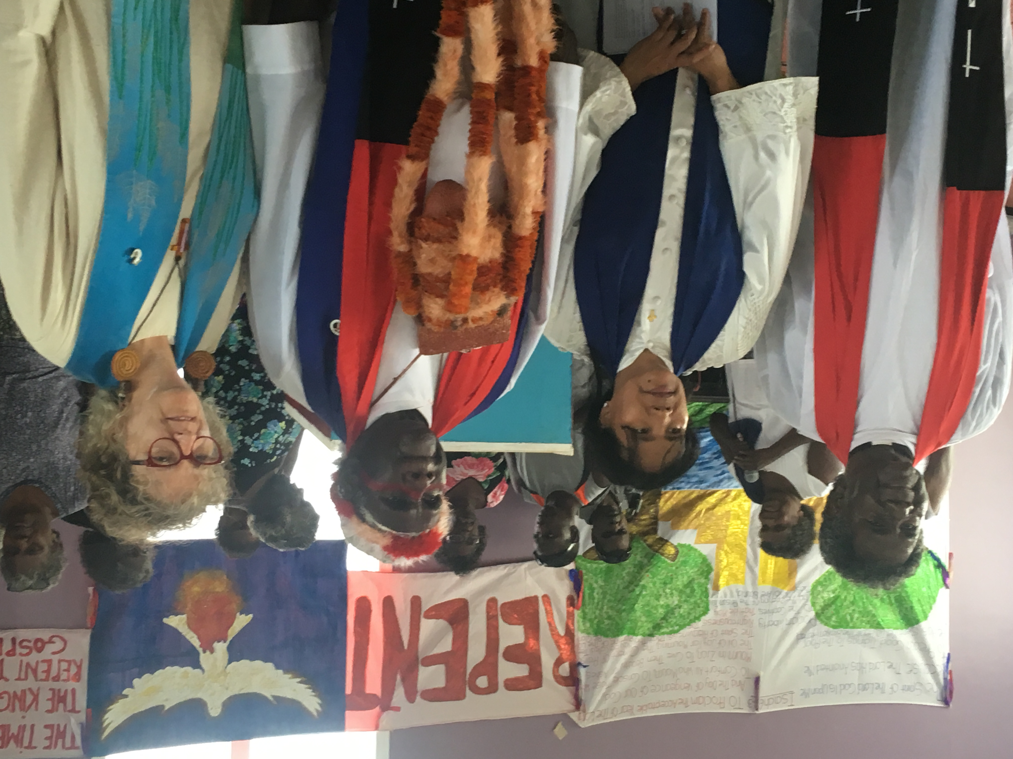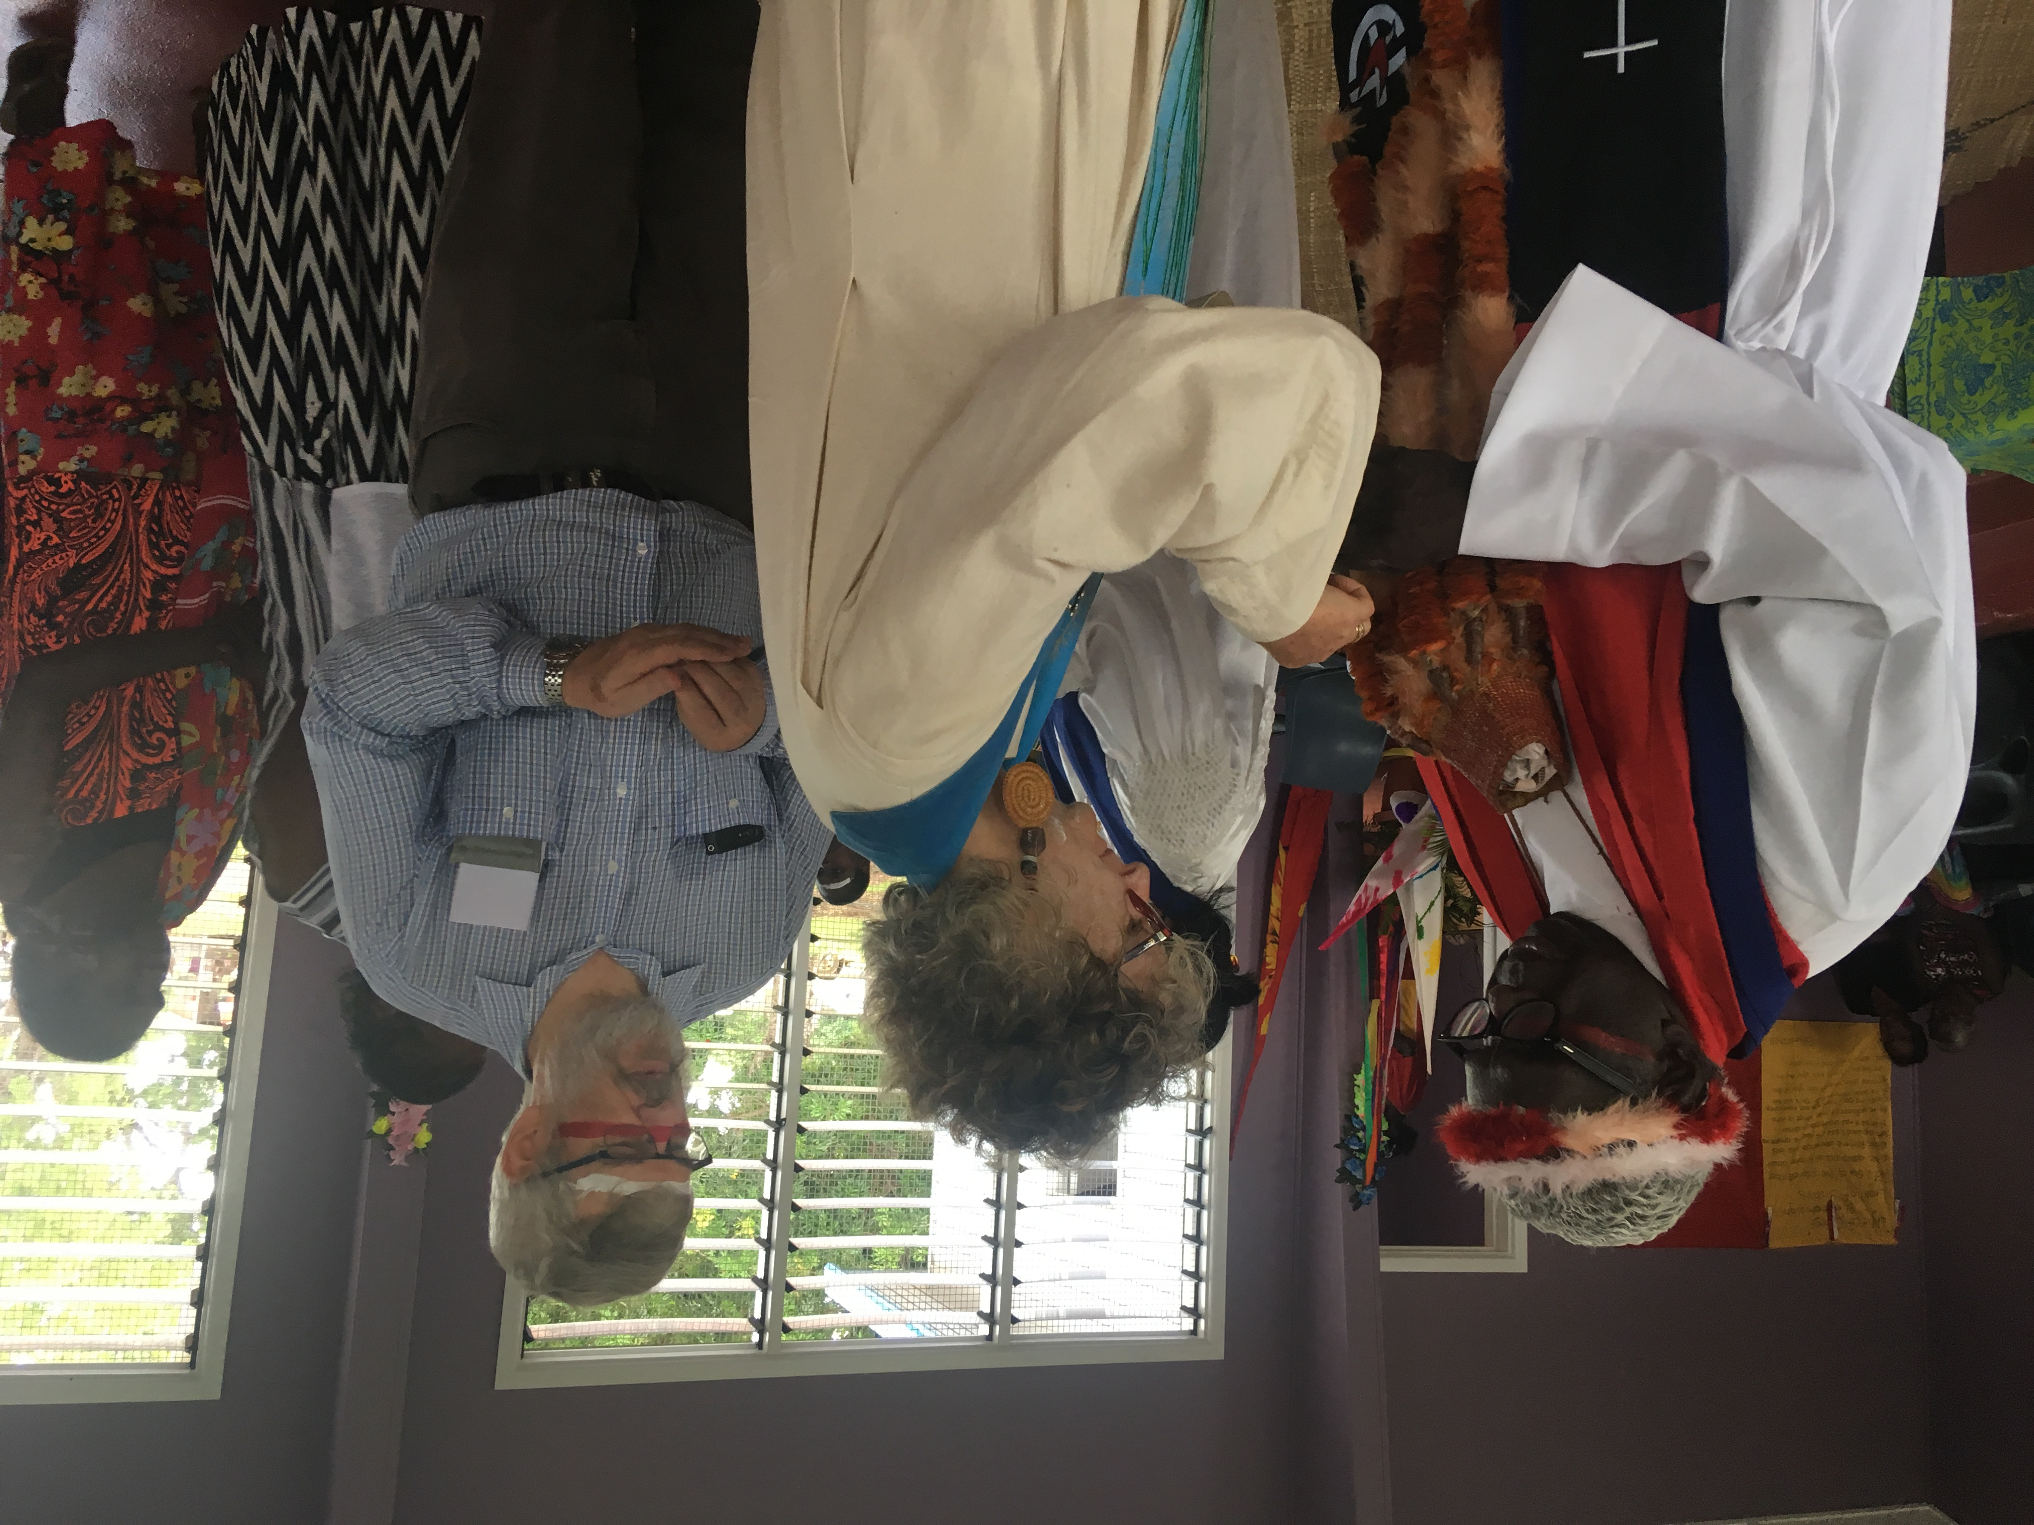

- give focus to ministry in remote and isolated areas
- PR&PC continues to work hard to fill congregational and other placements in the Presbytery.
- Rev David King commenced his placement with the Broome Congregation in March.
- Rev Helen Richmond commenced her placement with the Casuarina Congregation in February.
- Living Water Uniting Church is vacant but has a Supply Minister, Pastor Rosalie Clarke.
- Nightcliff Uniting Church is vacant and has Supply Ministers, Pastor Rosemary Hudson-Miller and Rev George Woodward.
- Nhulunbuy Uniting is also vacant and has a supply Minister, Rev Bob Smith.
- The new minister for Darwin Memorial, Rev Dr Andrew Williams will commence his placement in November.
- The new teacher for Nungalinya College Rev Michelle Cook will commence her new placement in January 2019.
- We continue to appreciate and value the leadership offered by Pastor Steve Bevis and Pastor Benjamin Quilliam in Alice Springs, Pastor Richard Telfer at Palmerston, Pastor Lauren Merritt at Darwin Memorial, Rev Peter Wait in Tennant Creek, Rev Tony Goodluck and Rev Lee Levitt Olsen at Nungalinya College, Pastor Sarah Pollitt at St Phillips, Pastor David Crawford at Royal Darwin Hospital, Rev Christine Senini, Rev Matthew Stuart and Rev Lief Fungalei with Defence Chaplaincy, Rev Jo Marr and Rev Lindsay Parkhill in Support Worker roles, and all those involved in School based chaplaincy in the Presbytery.
- Rev Wendell Flentji, Stephanie Gesling, Rev Salomo Bangun and Rev Myung Hwa Park have also done supply in the presbytery during the last year.
- All congregations in the Presbytery have and encourage Lay Preachers and Lay Worship leaders who make a considerable contribution to building up their congregations in faith. However very few of our Lay Preachers are accredited or comply with UCA requirements for Lay Preachers to meet general and core competencies (including Code of Ethics and Polity). The Presbytery will have conducted three great continuing education events for Lay Preachers during 2018. We have developed a pathway for people who attended to be accredited. We had great speakers and facilitators lined up and they were all ‘events not to be missed!’.
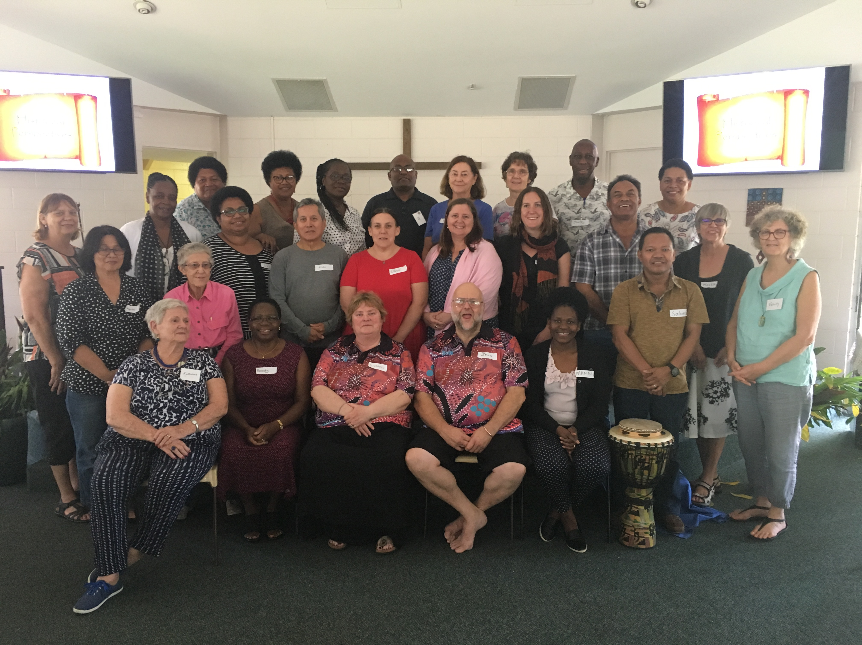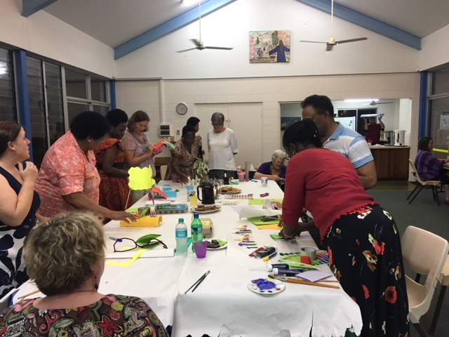

- I continue to travel regularly (both around congregations in the Darwin region as well as our more remote congregations) ensuring that congregations might have a growing sense of relationship with the Presbytery.
- There is a strong desire to explore how we might do some ‘pulpit exchange’. With costs and distances involved, this is not easy. However it does happen in the Darwin region. I am keen for the Executive to think about a creative and cost effective way to do this. We are hoping that technology will help us get around the expense.

- and support Chaplaincy and its connections with Congregations
- The Presbytery has a significant number of non congregationally based ministry agents, in schools, defence, hospital, agency and prison chaplaincy, Bush Chaplains, as well as our Nungalinya staff. At our February meeting of Presbytery we heard from them about their work and how congregations might better connect with what they are doing and support these ministries.
- The Presbytery will address a number of issues around supervision, providing continuing education and appropriate recognition for lay people involved in the servicing of these ministries. There is some particular work needing to be done with the School Chaplains.
- Rev Helen Paine and I have begun a conversation about how we might offer Code of Ethics in 2019 in a creative and ‘entertaining’ way, as our ministers, pastors and other lay leaders will all be ready for an update. I know you are all excited about that!
There have been other important things happening in the life of the presbytery that are worthy of note.
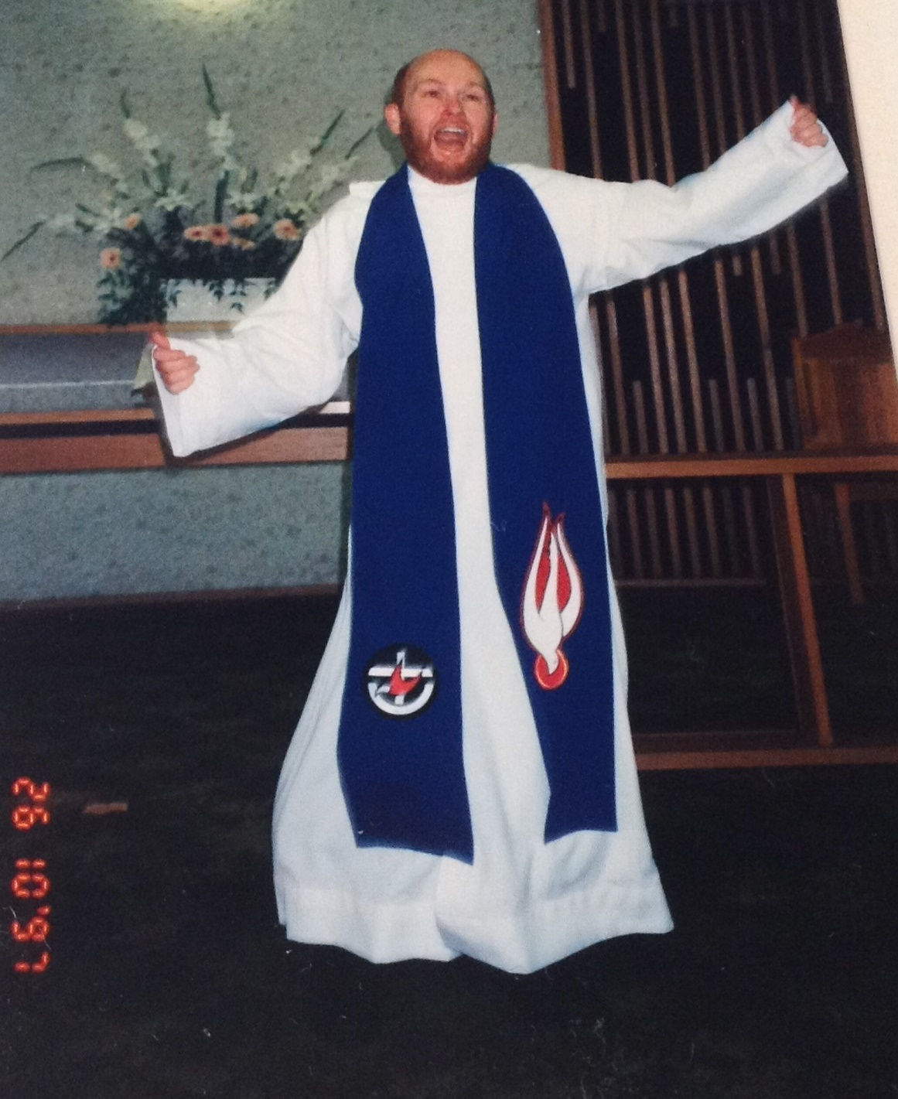
- The year has not been without some sadness. Ministers and lay members have lost colleagues in ministry and family members. Many of us continue to journey with very sick family and friends.
- I wish particularly to acknowledge the passing of Rev Chris Paine on 23rd August 2017. It has been a very sad time for Helen, and the family as well as the Broome Congregation. We remember Chris as a very lively person who loved to sing and dance and encourage others. He is sadly missed.
- On a happier note, we have two Candidates for the ministry. In conversation with Emily Hayes and Richard Telfer it was agreed that we would not send them interstate for ministry formation but work with E4M Committee and Adelaide College of Divinity to provide that formation locally. I wish to extend a special thanks to Rev Dr Andrew Dutney who has helped make this possible. Our thanks also to Rev Helen Paine and Rev Peter Wait for convening their Formation Panels and for all the other panel members involved. Please be encouraged to pray for them and to talk with Emily and Richard at Synod about their formation and their journey towards ordained leadership.
- We also have three people doing a period of discernment. Pastor Steve Bevis, David Hucker and Adrian Calyun-Sice. PR&PC will receive Learning Plans in coming weeks and look forward to journeying with them as they explore what particular ministry God is calling them too.
- We also want to celebrate the ‘a wedding in the family’. Congratulations to Jemma and Richard. Our blessings to them both, as they journey together in this very special relationship of marriage.
- Another highlight for the year has been our participation in the triennial meeting of the National Assembly. We encourage you to read and explore how your congregations might connect with, supporting and be supported by, the work of the Assembly.
