Report to Synod 2018
ARDS Board
The ARDS Board has grappled with serious sustainability issues this year. It has been recognised that ARDS cannot continue to rely on government funding alone, as the vagaries of funding rounds do not provide adequate certainty to allow for planning for future sustainability.
Our Board has participated in a number of strategic planning forums and has provided the team with a clear vision for the future of ARDS.
In response to the Board’s guidance, ARDS has developed a solid relationship with Uniting Care, National Office. This relationship supports ARDS with advocacy and access to key decision makers – important to enhancing ARDS’s profile and recognition of our unique work.
New Projects
We were successful in our submission to the Commonwealth through IAS funding to provide a Mediation and Restorative Justice Service to the people of Galiwinku.
We have also been engaged by the NTG to work with several communities in response to the issues related to Volatile Substance Abuse.
Our project work on Family Violence has been extended for another three years.

Project Success Stories
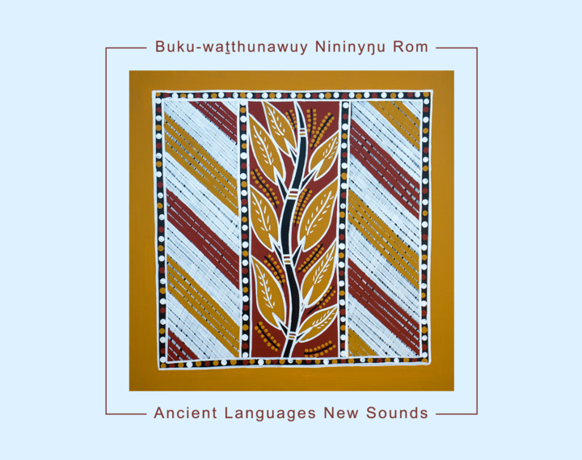
Our Project “Gurrangay Ancient Languages New Sounds” has achieved outstanding success winning a National Indigenous Music Award for Traditional Music.
The CD was a culmination of two years’ work across 4 Top End communities to record and document Yolngu Clan languages and songs.

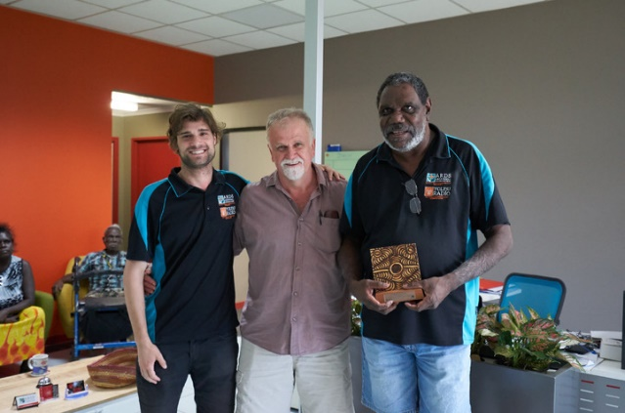
“Let’s talk about gambling” is a twelve part radio series funded by the NT Community Benefit Fund. The series was developed to “Find a pathway to reduce harms caused by pokies”. The series was awarded “Best Radio Production” at the 2017 Indigenous Remote Communications Association (IRCA). To build on this success, we prepared a submission to work further to stimulate further conversations about gambling and community resilience.

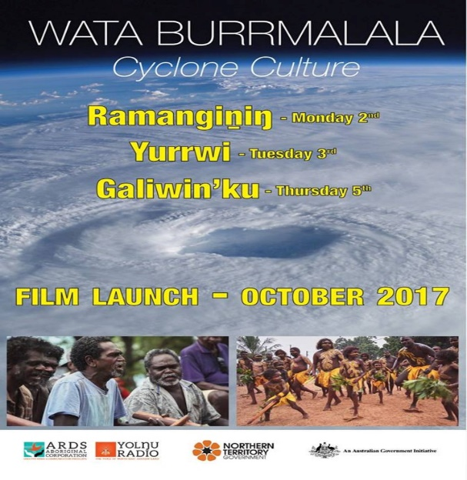
Film “Wata Burrmalala” – Cyclone Culture
Jointly funded by the NTG and Commonwealth government, this film is a documentary–style film that explores, celebrates and strengthens the capacity of Yolngu to prepare for, survive and recover from the impacts of tropical cyclones – an ongoing reality of life in Arnhem Land.

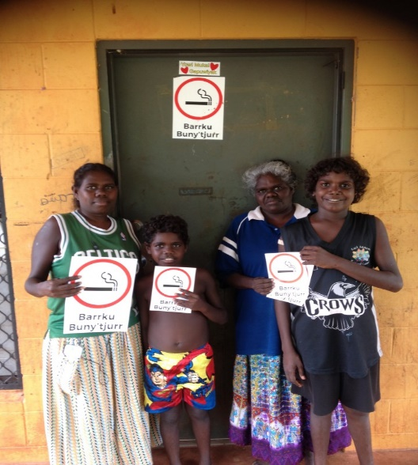
Smoke Free Spaces – Stories from Gapuwiyak
ARDS finished up almost a year of conversations with Yolngu in Gapuwiyak about smoke free spaces.
We believe these dialogues were, for many Gapuwiyak residents, the first time they have received meaningful information about cigarettes and passive smoking in their own language. After these discussions, many householders tried to start a “barrku buny’tjurr (smoke away in the distance) rule for their house.

Commercial Activity
The ARDS team has worked proactively to secure a number of contracts from a range of sources including:
- Power and Water to deliver important community information about essential services,
- Provision of sound services to a range of community functions and festivals,
- Development of a trial Cultural Competence Training program, and
- Providing support to Miwatj and ALPA to provide training for NDIS workers.

Looking Forward
Many mainstream agencies are now recognising the value of our unique way of working with Aboriginal communities and the value this brings to regional development. For ARDS to continue to be sustainable, it requires a dynamic approach to the way we work.
Our team and Board have continued to work with passion in an uncertain environment, to respond to many challenges. Without their significant effort, ARDS’s future would have been be quite bleak.
It is important that both the Board’s and the team’s effort be recognised and commended.

