PPNA PROFESSIONAL DEVELOPMENT

Special
INVITATION
TO ALL LAY PREACHERS & PASTORS

Professional Development & Lay Preacher Training

Tuesday 2nd & Wednesday 3rd October 2018

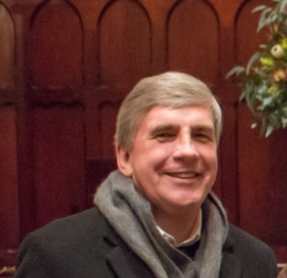

Special guest & facilitator Rev Dr Ian Price

‘Evangelism & Discipleship in Preaching’
Rev Dr Ian Price is Chief Executive Officer of MediaCom, an official agency of the South Australian Synod of the Uniting Church in Australia.
Ordained in 1978, Ian served three parishes in the Uniting Church in Australia, served briefly in New South Wales as the Executive Director of the UCA’s Board of Education, was MediaCom’s Associate Director from 1998 to 2002, and spent the last nine years heading the Uniting Church in South Australia’s Mission Resourcing Network with responsibilities in mission to children and youth, ministry with indigenous people, engaging in international mission partnerships, as well as rural and urban mission planning.
Ian is deeply committed to bringing the best resources to the Christian Church in discipleship, worship, faith formation and missional effectiveness. Through publishing, book and magazine distribution and consultancy, he seeks to serve the church with excellence

