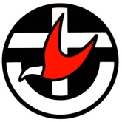 | Uniting Church in Australia  NORTHERN SYNOD

Gambling Intervention and On-going Recovery Support

Local cultural community access to informal conversation is the first point of contact. People need slow and gentle introduction to new ways of understanding, their gambling habit/additions. Once the topic is opened up, then refer to profession help.

Different cultural groups have barriers to coming to counselling sessions. We need to provide a multi-level series of support:

- Local starting point in non-judgemental ways;
- Refer to culturally aware counsellors at Somerville.
- Assist in joining a GA/12 Step on-going mutual support group.

